Driver Drowsiness Detection System

**Abhilash Maithani1, Ankul Kumar2, Rahul Lakhchaura3, Ritesh Kumar4**

B. Tech CSE (2019-23), Graphic Era Hill University Dehradun

**Abstract: *Road safety is a major concern for public health as avoiding it can lead to injuries and fatalities. Driver drowsiness is a major issue that results in several auto accidents each year. The focus of this research is to make the utmost effort to detect drowsiness in drivers during real-life driving situations. The aim of developing driver drowsiness detection systems is to minimize the occurrence of road accidents caused by drowsy driving.*** ***The paper suggests a technique that uses visual information in real-time to oversee the tiredness/ fatigue of drivers. The Dlib Python library is used in this work to demonstrate a method for extracting face features. The Dlib library is well-known in the field of machine learning and computer vision and offers a range of pre-trained models that can detect facial landmarks. To detect 68 specific facial landmarks on an image of a face, the approach proposed in this paper makes use of Dib’s pre-trained shape predictor model. Further we use the eye landmarks and SVM (Support vector machine) algorithm to determine EAR (Eye aspect Ratio).*** ***Next, we determine eyes state i.e., are the eyes are open or closed, and then assess the level of fatigue based on the sequence of eye states. A technique for detecting driver fatigue based on vision is a natural, convenient, and non-intrusive method for monitoring a driver's alertness.***

**Keywords:**Driver Drowsiness Detection, Dlib, EAR (Eye Aspect Ratio), SVM (Support Vector Machine), Eye Detection, Eye Tracking.

**I. INTRODU CTION**

There are various causes for highway traffic accidents, and one of the main factors is drowsy driving and driver fatigue. Driver fatigue and drowsiness are blamed for a huge portion of accidents, which are a major cause of injury and death globally. A survey conducted by the Central Road Research Institute (CRRI) on the 300-km Agra-Lucknow Expressway shows that fatigued drivers who fall asleep at the wheel cause 40% of traffic accidents. The study on tired drivers has brought attention to the necessity of educating highway drivers on the importance of taking regular breaks and getting adequate sleep for safety in a country where road accidents kill four lives every minute. There are several reasons why drivers may feel sleepy while driving, such as insufficient sleep, sleep-related health problems, certain medicines, alcohol, and other medical conditions. Driver fatigue and drowsiness continue to pose a significant issue for road safety despite attempts made to encourage safe driving practices. Here we suggested a project to create a real-time driver drowsiness detection system based on methods for sensing eyes to lessen the dangers related to driver inattention. The system will use measurements of the Eye Aspect Ratio (EAR) to identify minute changes in the driver's facial characteristics, acting as an early notification system to prompt the driver to prevent collisions. The suggested device will have a dashboard-mounted camera that records the driver's face and transmits the footage to a computer for analysis. The video stream will be analyzed using deep learning algorithms to find the driver's eyes. To detect drowsiness, the system will detect signs such as a high blink rate, drooping eyelids, and slow eye movement by monitoring the eye movement of the driver. The system suggested in the project will issue alerts to the driver in real-time when the level of driver drowsiness exceeds a predetermined threshold. Creating a reliable and accurate system for detecting driver drowsiness as proposed in the project can have a significant impact on improving road safety and reducing the frequency of accidents that occur due to driver fatigue and sleepiness.

**II.RELATED WORK**

Many studies have been done to investigate the use of computer vision techniques to identify signs of driver fatigue and drowsiness. Driver drowsiness is a key contributor to auto accidents. We have conducted a survey which includes the most recent developments and studies on this topic (Drowsiness detection). It was an attempt to understand better the amount of work that has been put into this field of research. Here we have carried out a literary survey on the topic of driver drowsiness detection using some of the latest technologies.

From [1] “Real-time driver drowsiness detection system using facial landmarks” by J. Kim et al. (2020) – Here J. Kim proposed a real-time drowsiness detection system using facial landmarks. To detect drowsiness, the authors suggested a method, in which using a convolutional neural network (CNN) they detect the 68 facial landmark, which are then used to detect the driver’s eye and mouth state which is further used to detect the drowsiness. The system provides an accuracy rate of 94.75%. There are some limitations in the paper that should be taken into consideration, Although the system detects sleepiness with a 94.75% accuracy rate, it may not function as well in different illumination environments because it depends on face landmark recognition.

From [2] “Driver Drowsiness Detection System Using Computer Vision” by Aditya Ranjan (2020)- In the given paper authors proposed a method in which facial landmarks features are used for driver drowsiness detection. Drowsiness is detected by analyzing the blink rate, they used E.A.R(eye aspect ratio) for easy and efficient blink detection. The presumption of a constant blink duration, even though everyone's blink length differs, is one of the study's problems.

From [3] “Drowsiness Detection Based on Eye Closure and Yawning Detection” - B. Mohana, C. M. Sheela Rani - In this study, Haar Cascade classifiers are used to track the movement of eyes and mouth. The yawning and eyes opening and closing frequency is tracked and based on that the drowsiness is determined. If the motorist is already sleeping or dozing off, the system will also trigger an alarm. The paper's restriction is the observation that the system's precision declines in poor lighting.

From [4] “Driver Drowsiness Detection by Applying Deep Learning Techniques to Sequences of Images” by Elena Magán, M. Paz Sesmero- this paper purposes a deep learning-based method for detecting driving fatigue. The suggested system uses an infrared camera to take sequences of pictures of the driver's face, which are then analyzed to look for signs of drowsiness. The images are passed to a convolutional neural network (CNN) and a long short-term memory network which then detect the signs of drowsiness.

From [5] "An Adaptive Driver Drowsiness Detection System using Eye Tracking and EEG Signals" by M. A. Adel et al. (2018) - This paper proposes a method of eye monitoring and EEG data, this paper proposes a technique for adaptive sleep detection. The system uses a combination of eye monitoring and EEG data to watch the driver's level of focus. The assessed data is then analyzed using machine learning methods to detect drowsiness. Limitation includes, While the system is adaptive in detecting changes in the driver's drowsiness level over time, it does not account for individual differences in drowsiness patterns or preferences. The system may also not adapt well to different driving environments or contexts.

In conclusion, the studies covered in this section suggest that facial feature analysis, particularly EAR and LAR, has the potential to be a non-invasive and precise method of identifying driver intoxication. Driver drowsiness detection systems may become more efficient at preventing accidents brought on by driver fatigue as computer vision techniques advance and other physiological measures are integrated.

**III. METHODOLOGY**

In the proposed system with the help of the CNN algorithm [14] and SVM (support vector machine) [15] we will detect real time drowsiness of the driver.

We utilize the CV2 module to capture live images of the driver we then detect face from the captured live image using HAAR cascade algorithm [12] and then feed them to algorithm, we are using the Dlib Library, which contains a trained CNN model that will extract 68 landmark points of the face [9], which are extracted facial features from the face images. Then out of the facial features i.e., 68 landmarks we use the eye landmarks (37-42 and 43-48) to calculate the EAR (Eye Aspect Ratio) [2], which tells us whether eyes are open or closed and then we note for how long the eyes are close if it is longer than threshold then an alert is raised, and we sound an alarm.

Figure 1. Steps to perform for driver drowsiness detection.

We are detecting whether eyes are open based on aspect ratio (EAR).

Eye state evaluation (EAR) can be computed according to the position of eye landmarks by:

EAR = ||p2 - p6|| + ||p3-p5|| / 2*||p1-p4||

p1 - p6: are the landmarks on the eyes.

If EAR is smaller than 0.25, and it is counted to 20 frames, then the person is drowsy and else the person is not drowsy.

**VI. RESULT**

**Step 1**: Take Image as Input from a Camera With a webcam, we will take images as input.



Figure 2. Capturing the image through CV2

**Step 2:** In this step we detect Region of Interest (ROI). For the suggested system, the ROI is eyes. To get ROI we need to first extract face form the image that we have taken as input in step 1. After that we convert the image into a greyscale image by using OpenCV and with the help of trained model and Haar Cascade classifier we detect face in the input image [12]. At last, we detect the eye landmarks in the face image and that will give us the Region of interest.

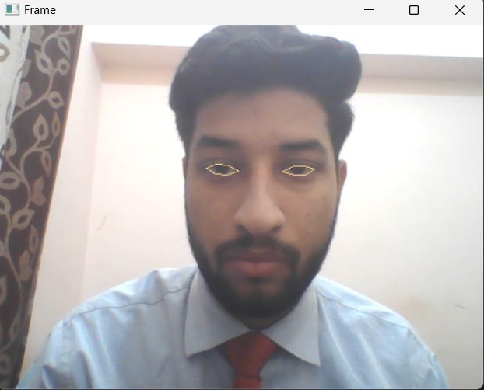

Figure 3. Detected the ROI.

**Step 3:** If the EAR is less than threshold for 20 frames the driver is alerted using the alarm.

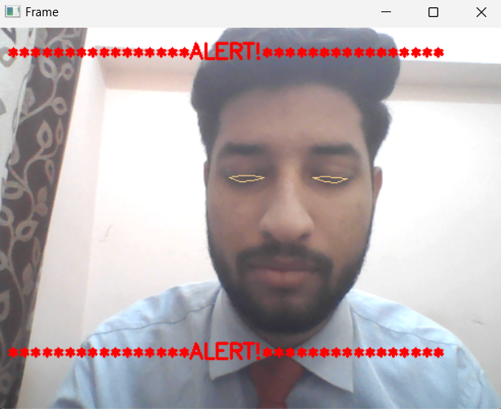

Figure 4. Eyes are closed and showing the alert.

**System Testing:**

The three test cases for driver drowsiness detection that were done as part of this research are represented in the following table.

Table 1: System Testing

|  |  |  |  |
| --- | --- | --- | --- |
| **Test Cases** | **Eye Spotted** | **Eye Close** | **Results** |
| Test Case 1 | No | No | No Alarm |
| Test Case 2 | Yes | No | No Alarm |
| Test Case 3 | Yes | Yes | Alarm Sound |

**IV. LIMITATIONS**

There are times when the method we are using to detect drowsiness is not effective, given below are some limitations of the method we are using.

1. one of which is when the users’ eyes are being covered, that can be if the user is wearing sunglasses, as the eyes are covered, we cannot detect the state of eyes i.e., if the eyes are in open or close state leading in the alarm being sound even when the user is not drowsy and vice versa.

2. Another problem arises when multiple people are being detected by the dashboard camera of the car, as the system will detect the eyes state for multiple people the system might end up giving wrong output and sound the alarm even when the driver is not drowsy this problem/ limitation is Multiple face problem

**VI. FUTURE WORK**

1. The same model and methods can be applied to a variety of other applications, such as allowing Netflix and other streaming services to recognize when a user is dozing off and stop the video accordingly.

2. The system that we have developed here is able to accurately detect drowsiness of any person and give an alert signal in the form of an audio alarm. But to prevent the accident it is not enough because even after the sounding audio alarm the accident prevention all depend upon if the driver can respond fast, so in case of slow reaction from driver due to fatigue or drowsiness we can install an automated motor-driven system that is timed to the warning signal to cause the vehicle to slow down.

3. Integration with wearable devices the use of advanced machine learning algorithms, such as deep learning, can further enhance the accuracy of the drowsiness detection system by learning

from previous data and making predictions based on it.

**VII. Conclusion**

In conclusion, creating a system for real-time driver drowsiness detection that uses eye detection methods has the potential to dramatically increase road safety and prevent accidents brought on by driver fatigue and drowsiness. Here the system that we have developed keeps track of the driver's facial traits, such eye movement and blink rate movement, to spot subtle variations in behavior that could be signs of tiredness. The suggested system computes the ocular aspect ratio from video data collected by a camera positioned on the car's dashboard to identify indicators of sleepiness (EAR). In this study, we proposed an EAR [2], Dlib, and SVM based driver drowsiness detection system [15]. In terms of detecting driver fatigue with high accuracy and an F1 score, the system displayed encouraging findings. The suggested technique can be utilized to stop accidents brought on by drowsy driving in the real world. The device warns the driver and the vehicle's control system in real time via visual and audio cues when the driver's sleepiness levels reach a set threshold, allowing the driver to take required precautions to prevent accidents. Large datasets of actual driving situations were used to assess the effectiveness of the suggested system, and the findings indicate that the system is extremely accurate and dependable at spotting driver intoxication.

To sum up, the suggested driver drowsiness detection system in this research study that combines EAR, Dlib, and SVM has proven to be successful in identifying driver tiredness with high accuracy and F1 score. There are three primary components of the system: face identification and tracking, eye region extraction and EAR computation, and SVM-based categorization [15]. The suggested technique can be employed in real-world situations to stop accidents brought on by drowsy driving. However, further research can be conducted to improve the system's accuracy and efficiency, such as combining unique features, using different classifiers [12], or exploring deep learning techniques [14].

**VIII. REFERENCES**

[1] “Real-time driver drowsiness detection system using facial landmarks” by J. Kim et al. (2020)

[2] Aditya Ranjan, Karan Vyas, Sujay Ghadge, Siddharth Patel, Suvarna Sanjay Pawar, “Driver Drowsiness Detection System Using Computer

Vision.,” the International Research Journal of Engineering and Technology (IRJET), 2020.

[3] B.Mohana, C.M.Sheela Rani, “Drowsiness Detection Based on Eye

Closure and Yawning Detection,” the International Research Journal of

Engineering and Technology (IRJET), 2019

[4] "Driver Drowsiness Detection by Applying Deep Learning Techniques to Sequences of Images" by Elena Magán, M. Paz Sesmero, Juan Manuel Alonso-Weber, and Araceli Sanchis, Computer Science and Engineering Department, Universidad Carlos III de Madrid, 28911 Leganés, Spain - 2022

[5] “An Adaptive Driver Drowsiness Detection System using Eye Tracking and EEG Signals” by M. A. Adel et al. (2018)

[6] “Joint face detection and alignment using multitask cascaded convolutional networks”, K. Zhang, Z. Zhang, Z. Li, and Y. Qiao, IEEE Signal Processing Letters, vol. 23, no. 10, pp. 1499-1503, Oct. 2016.

[7] F. J. Henriques, R. Caseiro, P. Martins and J. Batista, “Exploiting the circulant structure of tracking-by-detection with kernels”, Proceedings of the European Conference Computer Vision, pp. 702-715, 2012

[8] S. Abtahi, B. Hariri and S. Shirmohammadi, “Driver drowsiness monitoring based on yawning detection”, Proceedings of IEEE

International Control, Measurement, and Instrumentation (CMI), IEEE, pp. 1-4, May 2011.

[9] T. Danisman, I.M. Bilasco, C. Djeraba and N. Ihaddadene, “Drowsy driver detection system using eye blink patterns,” Universite Lille 1 &

Telecom Lille 1, Marconi, France, 2010.

[10] Information about the driver fatigue vision system developed by the PSA in

cooperation with the Technical University of Lausanne – 2017.

[11] B.A. Efraty, M. Papadakis, A. Proﬁtt, S. Shah and I.A. Kakadiaris “Facial component landmark detection” – ieee explore 2011.

[12] “Face detection using haar cascade classifier” by Bhavana R. Maale , Dr. Suvarna Nandyal- 2021

[13] “Real-Time Eye Blink Detection using Facial Landmarks” Tereza Soukupova and Jan ´ Cech, the Center for Machine Perception, the Department of Cybernetics Faculty of Electrical Engineering, Czech Technical University in Prague.

[14] F. N. Iandola, S. Han, M. W. Moskewicz, K. Ashraf, W. J. Dally, and K. Keutzer, "Squeezenet: Alexnet-level accuracy with 50x fewer parameters and <0.5Mb model size", Proceedings of the International Conference of Learning Representations, pp. 1-13, 2017.

[15] “Real Time Driver Fatigue Detection Based on SVM Algorithm” by Burcu Kır Savaş, Yaşar Becerikli -2018

[16] Bergasa, L.; Nuevo, J.; Sotelo, M.A.; Barea, R.; Guillén, M. Real-time system for monitoring driver vigilance. IEEE Trans. Intell. Transp. Syst. 2006,

[17] Lorente, M.P.S.; Lopez, E.M.; Florez, L.A.; Espino, A.L.; Martínez, J.A.I.; de Mi-guel, A.S. Explaining Deep Learning-Based Driver Models. Appl. Sci. 2021

[18] Dinges, D.F. An overview of sleepiness and accidents. J. Sleep Res. 1995